HIGHLEY PARISH COUNCIL
Clerk: Mrs E Preston
81 Woodhill Road, Highley, Bridgnorth, Shropshire, WV16 6HU
Telephone: 01746 861979
Email: clerk@highleyparish.couk

Date: 26th January 2021o: All Parish Council members
The Public and Press

You are summoned to atted an ordinary Meeting of Highley Parish Council which will be held via video link (Zoom) Tuesday 2nd February 2021 at 7pm for the transaction of business as set out in the agenda below.
Members of the public are invited to address the Council at the start of the meeting.

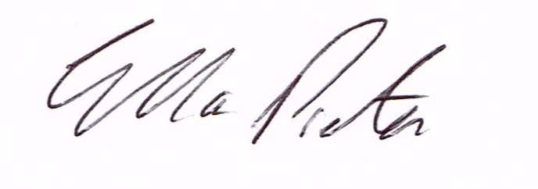
ELLA PRESTON
CLERK TO HIGHLEY PARISH COUNCIL.

AGENDA:

00. Parishioners Time (15 minutes) - Speaking at a Meeting - You do not have the right to speak at a meeting unless invited to do so by the Council. If you wish to speak /attend, then you must contact the Clerk beforehand so that a link to the meeting can be emailed to you.

Declaration of any disclosable pecuniary interest in a matter to be discussed at the meeting. Members are reminded that they are required to leave the room during the discussion and voting on matters in which they have a disclosable pecuniary interest, whether the interest is entered in the register of member’s interest maintained by the monitoring officer.

01 Apologies for absence and reasons for absence

02 To confirm the minutes of the meetings dated 5th January 2021

03. Election by co-option of Parish Councillor to fill vacant position. – Two applications received.

04. Matters Arising
CCTV – Update
Youth Project – Update from Cllr.Vinall.

05.Correspondence (All correspondence emailed to Councillors – if you wish anything discussed please contact the Clerk).
SALC – Census information
Slc – Eection Trainning – 26th February
SALC – News in Brief - Contact Information, Lockdown Summary
Severn Valley Country Park – Letter and Report

06. Planning

Address: The Caravan, Land Adjoining Abberley View, Church Street, Highley, Shropshire, WV16 6NA
Proposal: Variation of condition 1 attached to planning permission 17/03498/FUL dated 12/10/2017 for the temporary siting of a static caravan.
Applicant: Mr Brian Cook (The Caravan, Land Adjoining Abberley View, Church Street, Highey, Nr.Bridgnorth, WV16 6NA, Bridgnorth, Shropshire, WV16 4PX)

Planning Decisiosn
Reference: 20/04581/FUL (validated: 01/12/2020)
Address: 74 Yew Tree Grove, Woodhill, Highley, WV16 6DG
Proposal: Erection of a first floor side extension
Decision: Grant Permission

07. Email System – from December 2020 Meeting – email attached.

08. Silent Soilder Statue - Missing Siloutte

09. Community Governance Review – email attached

10. Medical Facilities – Cllr.Tremellen to give further information

11. Churchyard Maintenance – NALC Legal Topic Note Attached.

12. Maintenance Contractor – Request to increase rate of pay.

13. Shropshire Councillors Report. Attached.

13 Finance: Clerks Salary - HMRC – Tax and National Insurance. , S.J.Maintenance – Village Maintenance issues. Hiline Electricial – Christmas Lights . Plus, any other invoices received prior to meeting

