HIGHLEY PARISH COUNCIL
Clerk: Mrs E Preston
81 Woodhill Road, Highley, Bridgnorth, Shropshire, WV16 6HU
Telephone: 01746 861979
Email: clerk@highleyparish.couk

Date: 24th May 2021
To: All Parish Council members
The Public and Press

You are summoned to attend an ordinary Meeting of Highley Parish Council which will be held at the Severn Centre Highley on Tuesday 1st June l 2021 at 7pm for the transaction of business as set out in the agenda below.
Members of the public are invited to address the Council at the start of the meeting.

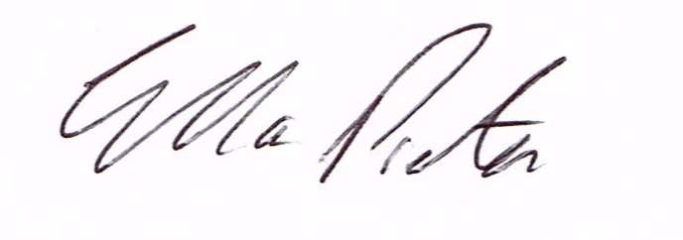
ELLA PRESTON
CLERK TO HIGHLEY PARISH COUNCIL.

AGENDA:

00. Parishioners Time (15 minutes) - Speaking at a Meeting - You do not have the right to speak at a meeting unless invited to do so by the Council. If you wish to speak /attend, then you must contact the Clerk beforehand so that a link to the meeting can be emailed to you.

Declaration of any disclosable pecuniary interest in a matter to be discussed at the meeting. Members are reminded that they are required to leave the room during the discussion and voting on matters in which they have a disclosable pecuniary interest, whether the interest is entered in the register of member’s interest maintained by the monitoring officer.

01. Welcome to New Councillors
Finish Committee Membership
CCTV Monitoring - Volunteer

02 Apologies for absence and reasons for absence

03 To confirm the minutes of the meetings dated 18th May 2021

04. Matters Arising
CCTV – Update
Youth Project – Update from Cllr.Vinall.
PCSO Shelley Hyde – Parish Priorities

05.Correspondence (All correspondence emailed to Councillors – if you wish anything discussed please contact the Clerk).
Police and Crime Commissioner – Survey
Western Power – Road Closure Netherton Lane – 2nd Augst 2021
SALC New in Brief

06. Planning

Can you please ensure that you look at these plans on Shropshire Councils planning portal prior to the meeting as we do not receive hard copies of the plans

PLANNING REFERENCE - 21/02188/FUL

DEVELOPMENT PROPOSED - Application under Section 73A of the Town and Country Planning Act 1990 for the retrospective change of use of land to accommodate two glamping pods and conversion of (part of) existing dwelling to form one holiday let property

LOCATION: - Proposed Caravan Site NW Of Millstone Cottage, Severn Side, Highley, Shropshire, . Reference: 21/02328/FUL (validated: 27/05/2021)

Address: 15 And 17 Ash Street, Woodhill, Highley, Bridgnorth, Shropshire, WV16 6HW
Proposal: Erection of single storey rear extension and porch to frontage of No.15 & No.17
Applicant: Mr Stephen Bowkett (15 & 17, Ash Street, Highley, WV16 6HW)

Planning Decisions

Reference: 21/01045/COU (validated: 23/03/2021)
Address: 20 Staley Grove, Highley, Bridgnorth, Shropshire, WV16 6FB
Proposal: Change of use from designated public open space to private residential curtilage
Decision: Grant Permission

Reference: 20/03697/OUT (validated: 15/09/2020)
Address: Land West Of, 13 Beech Street, Woodhill, Highley, Shropshire
Proposal: Outline application (all matters reserved) for the erection of one pair of semi-detached dwellingsPlanning Decisions published on 24/05/2021 relating to parish of: Highley

Reference: 21/00861/CPE (validated: 19/02/2021)
Address: Annexe, Romyra, Blything Court, Highley, Bridgnorth, Shropshire, WV16 6JL
Proposal: Application for Lawful Development Certificate for the existing use of annex as a dwelling
Decision: Certificate - Not Lawful

Decision: Refuse

07. Severn Centre- Management Fee

08.Grant Request – Highley Community Project

98. Grant Request – Highley Brownies

10.SALC – Affiliation Fees

11. Litter – from last meeting Cllr. A.Rodgers and Cllr. T.Quinn

12 Finance: Clerks Salary - HMRC – Tax and National Insurance. , S.J.Maintenance – Village Maintenance issues – Tech Services CCTV – Severn Centre ,. Plus, any other invoices received prior to meeting

