HIGHLEY PARISH COUNCIL
Clerk: Mrs E Preston
81 Woodhill Road, Highley, Bridgnorth, Shropshire, WV16 6HU
Telephone: 01746 861979
Email: clerk@highleyparish.couk
4th January 2022
To: All Parish Council members
The Public and Press

You are summoned to attend an ordinary Meeting of Highley Parish Council which will be held at the Severn Centre Highley on Tuesday 11th January 2022 at 7pm for the transaction of business as set out in the agenda below.

Members of the public are invited to address the Council at the start of the meeting . Please contact the Clerk before the start of the meeting if you wish to address the Council.

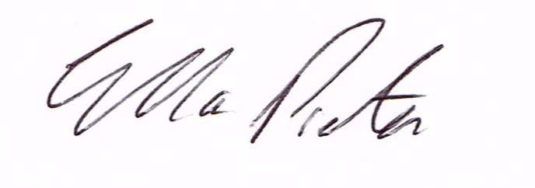
ELLA PRESTON
CLERK TO HIGHLEY PARISH COUNCIL.

AGENDA:

00. Parishioners Time (15 minutes) - Speaking at a Meeting - You do not have the right to speak at a meeting unless invited to do so by the Council. If you wish to speak /attend, then you must contact the Clerk beforehand so that a link to the meeting can be emailed to you.

Declaration of any disclosable pecuniary interest in a matter to be discussed at the meeting. Members are reminded that they are required to leave the room during the discussion and voting on matters in which they have a disclosable pecuniary interest, whether or not the interest is entered in the register of member’s interest maintained by the monitoring officer.

01.Election of Chair

02. Co-option of Parish Councillors

03 Apologies for absence and reasons for absence

04 To confirm the minutes of the meetings dated 8th December 2021.

05. Matters Arising
Youth Project – Update from Cllr.Vinall.
Welcome Back Fund – update.

06.Correspondence (All correspondence emailed to Councillors – if you wish anything discussed please contact the Clerk).
Mr.E.West, Shropshire Council – CIL – Future Working.
Salc – Christmas Newsletter
Road Closure: B4555 High Street, Highley. Start Date: 14th February 2022 - End Date: 20th February 2022.
Severn Centre – Partnerships Reports and Community Plans .
Ffion Horton – CIL funded Highways Report for Highley

07. Planning
Reference: 21/05871/FUL (validated: 17/12/2021)
Address: Glencoe , Bridgnorth Road, Highley, WV16 6ER
Proposal: Removal of existing garden boundary wall and replace with a 1.8m timber fence with concrete posts and associated works

Planning Reference - 21/05570/FUL
DEVELOPMENT PROPOSED - Alterations to existing dwelling and associated works
LOCATION: - The Cedars, Bridgnorth Road, Highley, Bridgnorth, Shropshire.

08.Precept 2022/2023 – To consider recommendations from the Revenue and Resources Committee for the 2022/2023 Precept.

09 – Queens Jubilee Celebrations – Cllr. J.Marshall

10. Climate Change Measures – Cllr. E.Moore – from last meeting

11. Highley First Responder – operational issues – Cllr.Vinall.

12. Shropshire Councils Report

13,Finance – M.E.Preston – Salary. HMRC Tax & NI. S.J.Maintenance – Maintenance Work. Severn Centre – Room Hire. Highline Electrical – Christmas Lights. OGL Computers – Email system – Plus, any other Cheques that come in prior to meeting.

