HIGHLEY PARISH COUNCIL
81 Woodhill Road, Highley, Bridgnorth, Shropshire, WV16 6HU
Telephone: 01746 861979
Email: prestonhighleypc@aol.com

Date: 27th March 2017.
To: All Parish Council members
The Public and Press

You are summoned to attend an Ordinary meeting of Highley Parish Council which will be held on Tuesday 4th April 2017 at the SEVERN CENTRE, HIGHLEY at 7.00pm for the transaction of business as set out in the agenda below.
Members of the public are invited to address the Council at the start of the meeting.

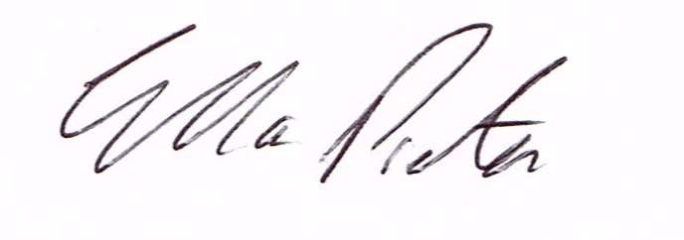
ELLA PRESTON
CLERK TO HIGHLEY PARISH COUNCIL.

AGENDA:

00. Parishioners Time (15 minutes) Speaking at a Meeting - You do not have the right to speak at a meeting unless invited to do so by the Council. If you wish to speak then you must contact the Clerk beforehand or make yourself known to the Clerk at the start of the meeting.

Declaration of any disclosable pecuniary interest in a matter to be discussed at the meeting. Members are reminded that they are required to leave the room during the discussion and voting on matters in which they have a disclosable pecuniary interest, whether or not the interest is entered in the register of member’s interest maintained by the monitoring officer.

01. Apologies for absence.

02. To confirm the minutes of the meeting dated 7th March 2017

03. Matters arising from minutes:-
Highley Swimming Pool – Update.
Dog Fouling - Update
Footpath 0127/42/1 - Jubilee Drive to Netherton Lane - Update
Plus any other matters arising information received prior to the meeting.

04. Correspondence:
Shropshire Council – information of CIL funds
SALC – Information Bulletin
Healthwatch Shropshire – Experience of Care Week.
Shropshire Council – Andrew Gough – CCTV Surveillance camera Strategy.
Shropshire Council – Economic Growth Strategy.
Plus any other correspondence that comes in prior to the meeting.

05 To look at any planning applications received.
Planning Decision
17/00300/FUL – Erection of single storey side extension – Beechcroft, Bridgnorth Road – GRANT PERMISSION.

06. Neighbourhood Watch – Request to purchase Hi-Viz Jackets and Torches – Mr.D.Tremellen – Neighbourhood Watch Co-ordinator. (Information enclosed.)

07. Shropshire Councillors Report.

08. Finance: Accounts outstanding: Clerks Salary. Post Office Counters -Tax and National Insurance.
APS – Pool Refurbishment Eon – Street Lighting
Plus any cheques that come in prior to meeting.

CORRESPONDENCE
All correspondence and plans will be available for inspection by Parish Councillors prior to the meeting by contacting the clerk or from 6.30pm on the night of the Parish Council meeting. Parish Councillors if you wish any item to be discussed at the meeting please inform the clerk.

