HIGHLEY PARISH COUNCIL
Clerk: Mrs E Preston
81 Woodhill Road, Highley, Bridgnorth, Shropshire, WV16 6HU
Telephone: 01746 861979
Email: prestonhighleypc@aol.com

Date: 28th November 2016.
To: All Parish Council members
The Public and Press

You are summoned to attend an Ordinary meeting of Highley Parish Council which will be held on Tuesday 6th December 2016 at the SEVERN CENTRE, HIGHLEY at 7.00pm for the transaction of business as set out in the agenda below.
Members of the public are invited to address the Council at the start of the meeting.

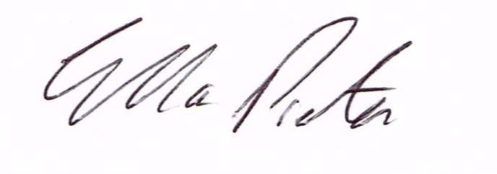
ELLA PRESTON
CLERK TO HIGHLEY PARISH COUNCIL.

AGENDA:

00. Parishioners Time (15 minutes)

Declaration of any disclosable pecuniary interest in a matter to be discussed at the meeting. Members are reminded that they are required to leave the room during the discussion and voting on matters in which they have a disclosable pecuniary interest, whether or not the interest is entered in the register of member’s interest maintained by the monitoring officer.

01. Apologies for absence.
02. To confirm the minutes of the meeting dated 1st November 2016 and Extraordinary
Meeting held 22nd November 2016
03. Matters arising from minutes:-
3.1. Highley Swimming Pool – Update
3.2. Highley Village Survey – Results
3.3. Churchyard – On Agenda
04. Correspondence:
4.1. Rural Services Network – Newsletter
4.2. Shropshire Housing Group –
4.3. Shropshire Hills AONB Partnership
4.4. SALC – Bulletin
4.5. Connecting Shropshire – November update

05. To look at any planning applications received.
06. CCTV Maintenance Agreement – from last meeting.
07. Churchyard Meeting – Report from Meeting.
08. Replacement of Setts in Village Centre – Email Graham Downes.
10. Shropshire Councillors Report.
11. Finance: Accounts outstanding: Clerks Salary. Tax and National Insurance.
Eon – Street Lighting. Lights. T.Preece Builders – Bus Shelters, Turnocks – Christmas
Lights Repair/Renewals. C.Holford – Christmas Lights. Plus any cheques that come in
Prior to meeting.

CORRESPONDENCE
All correspondence and plans will be available for inspection by Parish Councillors prior to the meeting by contacting the clerk or from 6.30pm on the night of the Parish Council meeting. Parish Councillors if you wish any item to be discussed at the meeting please inform the clerk.

