HIGHLEY PARISH COUNCIL
Clerk: Mrs E Preston
81 Woodhill Road, Highley, Bridgnorth, Shropshire, WV16 6HU
Telephone: 01746 861979
Email: clerk@highleyparish.couk

Date: 24th November 2019
To: All Parish Council members
The Public and Press

You are summoned to attend an ordinary Meeting of Highley Parish Council which will be held on Tuesday 3rd December 2019 at the SEVERN CENTRE, HIGHLEY at 7pm for the transaction of business as set out in the agenda below.
Members of the public are invited to address the Council at the start of the meeting.

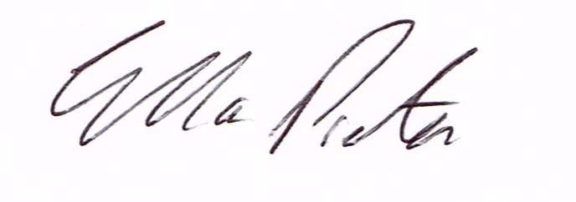
ELLA PRESTON
CLERK TO HIGHLEY PARISH COUNCIL.

AGENDA:

00. Parishioners Time (15 minutes) - Speaking at a Meeting - You do not have the right to speak at a meeting unless invited to do so by the Council. If you wish to speak then you must contact the Clerk beforehand or make yourself known to the Clerk/Chair at the start of the meeting.

Declaration of any disclosable pecuniary interest in a matter to be discussed at the meeting. Members are reminded that they are required to leave the room during the discussion and voting on matters in which they have a disclosable pecuniary interest, whether the interest is entered in the register of member’s interest maintained by the monitoring officer.

01. Apologies for absence.

02. To confirm the minutes of the meeting dated 5th November 2019

03. Matters Arising
Church Street - – Awaiting a reply from Shropshire Council regarding parking problems.
Castle Inn Update – Shropshire Council - Awaiting update from Shropshire Council.
CCTV - Awaiting Quotations from Eon and Tech Services regarding additional work.
Parking Bays Village Centre/Lines Coronation Street - Awaiting response from Shropshire Council.
Staley Grove - Fencing - Reply from Hawk Development
Defibulator Update
Right Home Right Place Survey
Road Repairs - Reply from Steve Brown re plastic use.

04. Correspondence (All correspondence emailed to Councillors)
Shropshire Council BT Payphone Removal
SALC - November Newsletter
SALC - Monday Newsletter re Funding Streams/National Tree Week/Strenting Police Powers to tackle encampments.
Severn Valley Country Park - Newsletter
Highley Mining Heritage Group - Event at Severn Centre

Plus any other correspondence received prior to meeting

05. Planning

Reference: 19/04869/FUL (validated: 12/11/2019)
Address: Glen Cottage, High Street, Highley, Bridgnorth, Shropshire, WV16 6LF
Proposal: Change of use from commercial garage to funeral directors’ premises and re-location of shop and associated works
Applicant: Mr C Adams (Perry And Phillips Ltd, Underhill Street, Bridgnorth, WV16 4BB)

Planning Decision
Reference: 19/04301/FUL (validated: 14/10/2019)
Address: No1 And No2 Cockshutt Lane, Highley, Bridgnorth, Shropshire, WV16 6JL
Proposal: Erection of 1 block of 2 garages with first floor amenity space (to serve both properties)
Decision: Refuse

06.Severn Centre - Reports

07. Glen Cottage, High Street, Highley - email sent to All Councillors.

08. Severn Valley Country Park - Grant Request - email sent to Councillors

09. SALC AGM - Report from meeting- Cllrs. G.Court/N.Barker

10.Shropshire Councillors Report. - Report to follow

11. Finance: Clerks Salary - HMRC – Tax and National Insurance. Severn Centre Trust – Room Hire, Eon – Street Lighting, S.J.Maintenance – Village Maintenance issues. SLCC - Subscription. Plus any payments that come in prior to meeting.

