HIGHLEY PARISH COUNCIL
Clerk: Mrs E Preston
81 Woodhill Road, Highley, Bridgnorth, Shropshire, WV16 6HU
Telephone: 01746 861979
Email: clerk@highleyparish.couk

Date: 24th November 2020
To: All Parish Council members
The Public and Press

You are summoned to attend an ordinary Meeting of Highley Parish Council which will be held via video link (Zoom) Tuesday 1st December 2020 at 7pm for the transaction of business as set out in the agenda below.
Members of the public are invited to address the Council at the start of the meeting.

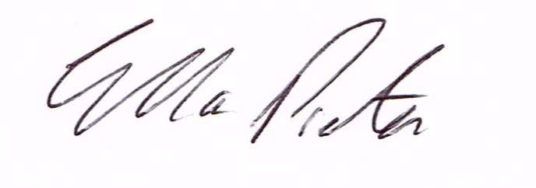
ELLA PRESTON
CLERK TO HIGHLEY PARISH COUNCIL.

AGENDA:

00. Parishioners Time (15 minutes) - Speaking at a Meeting - You do not have the right to speak at a meeting unless invited to do so by the Council. If you wish to speak /attend, then you must contact the Clerk beforehand so that a link to the meeting can be emailed to you.

Declaration of any disclosable pecuniary interest in a matter to be discussed at the meeting. Members are reminded that they are required to leave the room during the discussion and voting on matters in which they have a disclosable pecuniary interest, whether the interest is entered in the register of member’s interest maintained by the monitoring officer.

01 Apologies for absence and reasons for absence

02 To confirm the minutes of the meetings dated 3rd and 17th November

03. Matters Arising
CCTV – Tech Services woking on system
Youth Project – Update from Cllr.Vinall.
Land Corner Beech Street/Hazelwell Road – Update – Clerk
Report from SALC AGM – Cllr.D.Tremellen and D.Bayley

06.Correspondence (All correspondence emailed to Councillors – if you wish anything discussed please contact the Clerk).

07. Planning

Reference: 20/04605/FUL (validated: 09/11/2020)
Address: 9 Sycamore Way, Woodhill, Highley, WV16 6DQ
Proposal: Erection of a single storey front extension and first floor side extension
Applicant: Mr. and Mrs. T. Quinn (9, Sycamore Way, Woodhill, Highley, WV16 6DQ)

08. Shropshire Councillors Report. Report to folllow.

09 Finance: Clerks Salary - HMRC – Tax and National Insurance. , S.J.Maintenance – Village Maintenance issues. Hiline Electricial – Christmas Lights Installation . Plus, any other invoices received prior to meeting

