HIGHLEY PARISH COUNCIL
Clerk: Mrs E Preston
81 Woodhill Road, Highley, Bridgnorth, Shropshire, WV16 6HU
Telephone: 01746 861979
Email: prestonhighleypc@aol.com

Date: 23rd July 2020
To: All Parish Councillors
The Public and Press

You are summoned to attend an Extraordinary meeting of Highley Parish Council which will be held on Thursday 30th July 2020 via Video Conferencing (Zoom) at 7.00pm for the transaction of business as set out in the agenda below. If any parishioners wish to attend the meeting can you please contact the clerk at highleyparish.co.uk by Wednesday 29th July 2020 so a link to join the Zoom meeting can be sent to you.

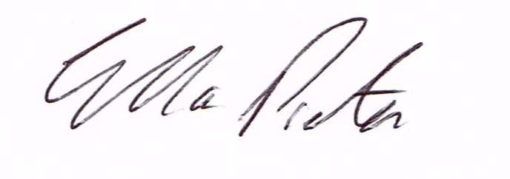

E.Preston
Clerk Highley Parish Council

AGENDA:

Declaration of any disclosable pecuniary interest in a matter to be discussed at the meeting. Members are reminded that they are required to leave the room during the discussion and voting on matters in which they have a disclosable pecuniary interest, whether or not the interest is entered in the register of member’s interest maintained by the monitoring officer.

01. Parishioners Time
02. Apologies for absence. And reasons for abscence
03. CIL Local Fund – To discuss allocation of CIL Local Fund

