HIGHLEY PARISH COUNCIL
81 Woodhill Road, Highley, Bridgnorth, Shropshire, WV16 6HU
Telephone: 01746 861979
Email: prestonhighleypc@aol.com

Date: 29th January 2017.
To: All Parish Council members
The Public and Press

You are summoned to attend an Ordinary meeting of Highley Parish Council which will be held on Tuesday 7th February 2017 at the SEVERN CENTRE, HIGHLEY at 7.00pm for the transaction of business as set out in the agenda below.
Members of the public are invited to address the Council at the start of the meeting.
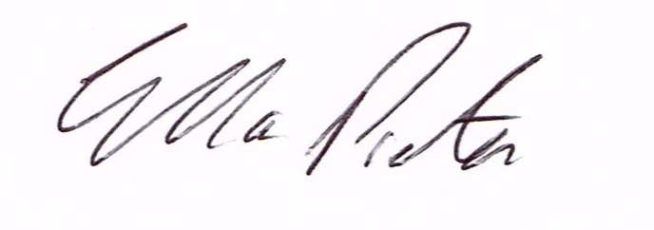
ELLA PRESTON
CLERK TO HIGHLEY PARISH COUNCIL.

AGENDA:

00. Parishioners Time (15 minutes)

Declaration of any disclosable pecuniary interest in a matter to be discussed at the meeting. Members are reminded that they are required to leave the room during the discussion and voting on matters in which they have a disclosable pecuniary interest, whether or not the interest is entered in the register of member’s interest maintained by the monitoring officer.

01. Shaun Sutton, Environmental Enforcement Supervisor – Shropshire Council, Graham Downes, Highways Manager Shropshire Council , PC A. O’Leary West Mercia Police.
02. Apologies for absence.
03. To confirm the minutes of the meeting dated 10th January 2017
04. Matters arising from minutes:-
Martin Sutton – Location of Tree Preservation Orders
Swimming Pool – Update
05. Correspondence:
SALC – How to recruit and Manage Volunteers – Training 21/7/17
Shropshire Council – Town and Parish Forum Meeting 27th February 2017
Police and Crime Commissioner - Newsletter
SALC – Information on Community Housing Fund
Shropshire Council – Partial Review of Shropshire Local Plan
Plus any other correspondence that comes in prior to the meeting.
06 To look at any planning applications received.
07. Churchyard Maintenance Contract – To agree contract for 2017. – (Enclosed)
08. Annual Parish Meeting – 25th April 2017 – to agree Topic for meeting.
09. Shropshire Councillors Report.
10. Finance: Accounts outstanding: Clerks Salary. Post Office Counters -Tax and National Insurance.
Eon – Street Lighting. N.Power - Street Lights. Severn Centre – Village Maintenance. B.White Nurseries – Flower Planting. Plus any cheques that come in prior to meeting.
CORRESPONDENCE
All correspondence and plans will be available for inspection by Parish Councillors prior to the meeting by contacting the clerk or from 6.30pm on the night of the Parish Council meeting. Parish Councillors if you wish any item to be discussed at the meeting please inform the clerk.

