HIGHLEY PARISH COUNCIL
Clerk: Mrs E Preston
81 Woodhill Road, Highley, Bridgnorth, Shropshire, WV16 6HU
Telephone: 01746 861979
Email: prestonhighleypc@aol.com

Date: 13th November 2017
To: Finance and Resources Committee – Cllr.D.Tremellen, M.Brooks, N.Barker, J.Law, G.Court, D.Thakrar, and A.Honeybourne, J.Marshall

You are summoned to attend a meeting of The Revenue and Resources Committee of Highley Parish Council which will be held on Thursday 23rd November 2017 at the SEVERN CENTRE, HIGHLEY at 10.00am for the transaction of business as set out in the agenda below.

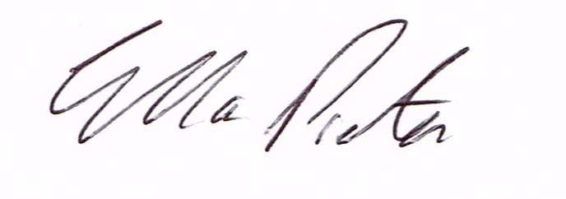

E.Preston
Clerk Highley Parish Council

AGENDA:

Declaration of any disclosable pecuniary interest in a matter to be discussed at the meeting. Members are reminded that they are required to leave the room during the discussion and voting on matters in which they have a disclosable pecuniary interest, whether or not the interest is entered in the register of member’s interest maintained by the monitoring officer.

01. Apologies for absence.
02. To approve minutes of meeting held on 11th October 2017
03 Clerks Annual Review
04. To discuss Precept Requirements for 2018/2019

