HIGHLEY PARISH COUNCIL
Clerk: Mrs E Preston
81 Woodhill Road, Highley, Bridgnorth, Shropshire, WV16 6HU
Telephone: 01746 861979
Email: prestonhighleypc@aol.com

Date: 14th May 2018
To: Finance and Resources Committee – Cllr.D.Tremellen, M.Brooks, N.Barker, G.Court, D.Thakrar, and A.Honeybourne, J.Marshall

You are summoned to attend a meeting of The Revenue and Resources Committee of Highley Parish Council which will be held on Tuesday 22nd May the SEVERN CENTRE, HIGHLEY at 7.00pm for the transaction of business as set out in the agenda below.

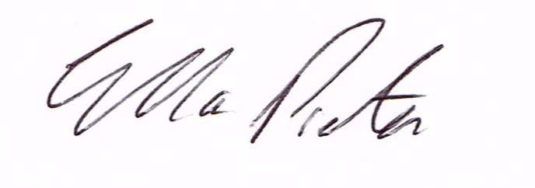

E.Preston
Clerk Highley Parish Council

AGENDA:

Declaration of any disclosable pecuniary interest in a matter to be discussed at the meeting. Members are reminded that they are required to leave the room during the discussion and voting on matters in which they have a disclosable pecuniary interest, whether or not the interest is entered in the register of member’s interest maintained by the monitoring officer.

01. Apologies for absence.
02. To approve minutes of meeting held on 23rd November 2017.
03. Parish Council Accounts – End of Year and Internal Auditors Report 2017/18
04. New Model Standing Orders
05. CIL – Neighbourhood Fund and CIL Local.
06. Microphone for Parish Council meetings.

