HIGHLEY PARISH COUNCIL
Clerk: Mrs E Preston
81 Woodhill Road, Highley, Bridgnorth, Shropshire, WV16 6HU
Telephone: 01746 861979
Email: clerk@highleyparish.couk

Date: 27th December 2019
To: All Parish Council members
The Public and Press

You are summoned to attend an ordinary Meeting of Highley Parish Council which will be held on Tuesday 7th January 2020 at the SEVERN CENTRE, HIGHLEY at 7pm for the transaction of business as set out in the agenda below.
Members of the public are invited to address the Council at the start of the meeting.

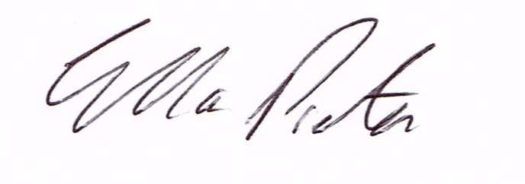
ELLA PRESTON
CLERK TO HIGHLEY PARISH COUNCIL.

AGENDA:

00. Parishioners Time (15 minutes) - Speaking at a Meeting - You do not have the right to speak at a meeting unless invited to do so by the Council. If you wish to speak then you must contact the Clerk beforehand or make yourself known to the Clerk/Chair at the start of the meeting.

Declaration of any disclosable pecuniary interest in a matter to be discussed at the meeting. Members are reminded that they are required to leave the room during the discussion and voting on matters in which they have a disclosable pecuniary interest, whether the interest is entered in the register of member’s interest maintained by the monitoring officer.

01. Apologies and reasons for absence.

02. To confirm the minutes of the meeting dated 3rd December 2019

03. Matters Arising/Clerks Report
Church Street - – Awaiting a reply from Shropshire Council regarding parking problems.
Castle Inn Update – Shropshire Council - Awaiting update from Shropshire Council.
Parking Bays Village Centre/Lines Coronation Street - Awaiting response from Shropshire Council.
Staley Grove - Photographs to be sent to Hawk Developments.
Right Home Right Place Survey -Update Tracey Johnson - Survey brought forward to June 2020
Severn Valley Country Park - Agreed to attend February 2020 Meeting
Crossing Village Centre - Reported crossing needing repainting and Beacon needing repairing to Shropshire Council.

04. Correspondence (All correspondence emailed to Councillors)
Shropshire Council - Building Control Team staffing information
SALC Area Committee - Thursday 16th January 2020
SALC - Election Results
Shropshire Rural Buses - Newsletter
SALC - Legal Topic Note - Repairs relating to Church Buildings
Rural Services Network - Newsletter
NALC - New Section 137 Expenditure Limit
Plus any other correspondence received prior to meeting

05. Planning

Reference: 19/05303/FUL (validated: 04/12/2019)
Address: Land at Church Street, Highley, Bridgnorth, Shropshire, WV16 6NA
Proposal: Erection of 1no dwelling following demolition of existing garage

Tree Preservation Order - Land at Abdon Close, Staley Grove, Wyre Close - confirmed order.

06.Severn Centre - No Report.

07. CCTV - Additional quotations from Technical Services/Eon - to agree additional expenditure

08. Precept 2020/21 - To agree recommendations from Finance and Resources Committee. Details emailed to all Councillors

09.Container Parish Council - To look at purchasing an alternative storage container.

10. Bache Arms Public House - Letter and petition - Cllr. D.Scriven

11.Shropshire Councillors Report. - No Report.

12. Finance: Clerks Salary - HMRC – Tax and National Insurance. Severn Centre Trust – Room Hire, Eon – Street Lighting, S.J.Maintenance – Village Maintenance issues. Severn Centre - Room Hire SALC - Training. Plus any other invoices received prior to meeting

