HIGHLEY PARISH COUNCIL
Clerk: Mrs E Preston
81 Woodhill Road, Highley, Bridgnorth, Shropshire, WV16 6HU
Telephone: 01746 861979
Email: prestonhighleypc@aol.com

Date: 27th June 2016.
To: All Parish Council members
The Public and Press

You are summoned to attend an Ordinary meeting of Highley Parish Council which will be held on Tuesday 5th July 2016 at the SEVERN CENTRE, HIGHLEY at 7.00pm for the transaction of business as set out in the agenda below.
Members of the public are invited to address the Council at the start of the meeting.

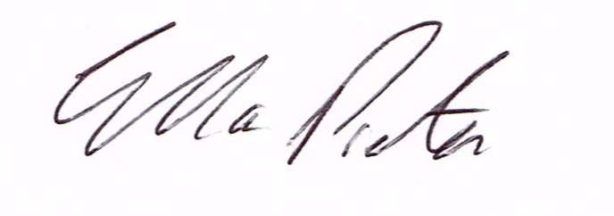
ELLA PRESTON
CLERK TO HIGHLEY PARISH COUNCIL.

AGENDA:

00. Parishioners Time (15 minutes)

Declaration of any disclosable pecuniary interest in a matter to be discussed at the meeting. Members are reminded that they are required to leave the room during the discussion and voting on matters in which they have a disclosable pecuniary interest, whether or not the interest is entered in the register of member’s interest maintained by the monitoring officer.

01. Apologies for absence.
02. To confirm the minutes of the meeting dated 7th June 2016
03. Matters arising from minutes:-
Highley Swimming Pool – Update
George Candler – Shropshire Council – Proposed Cuts to Shropshire Council Budget
Clive Wright – Shropshire Council – Report From meeting between Shropshire Council and Town and Parish Councils
Martin Whitelegg – Star Housing – Parking Rhea Hall.

04. Correspondence:
Graham Moore, Shropshire Council – Christmas Lighting permissions.
Public Sector Show – Invitation to attend at Manchester 22nd November 2016
Shrewsbury and Telford Hospital Trust – Media Release – Hospital Trust Improves in survey of patient satisfaction.
Shropshire Council - Advanced Notice of Road Closure – B4555 Highley New Road –
Shropshire Council – Shropshire HR – Showcase to Town and Parish Councils – Friday 1st July 2pm – 4pm Shrewsbury
Rural Services Network – Newsletter
Shropshire Housing Group – Invitation to event on “What Communities Can Do” on 13th July.
Plus any correspondence received before meeting
05. To look at any planning applications received.
16/02181/FUL – Erection of first floor extension – 8 Redstone Drive Highley.
06. Shropshire Council Proposed Cuts - Reports from meeting with Chris Edwards – Area Commission Shropshire Council – Enclosed.
Report from meeting held at the Guildhall Shrewsbury – Cllr.Barker
Report from Bridgnorth SALC Area Committee Meeting 22nd April 2016
Report from Meeting at Cantern Brook regarding Severn Valley Country Park.
07. Speed/Dangerous Parking – Cllr.Phipson – information enclosed.
08. Shropshire Councillors Report.
09. Finance: Accounts outstanding: Clerks Salary. Tax and National Insurance.
Eon – Street Lighting. Severn Centre- Churchyard Maintenance. Severn Centre –
Parish Council Maintenance. SALC – Training D.Tremellen. Proludic – New Play Area
Equipment. Bill White – Plants for Highley Village.
Plus any cheques that come in prior to meeting.

CORRESPONDENCE
All correspondence and plans will be available for inspection by Parish Councillors prior to the meeting by contacting the clerk or from 6.30pm on the night of the Parish Council meeting. Parish Councillors if you wish any item to be discussed at the meeting please inform the clerk.

