HIGHLEY PARISH COUNCIL
81 Woodhill Road, Highley, Bridgnorth, Shropshire, WV16 6HU
Telephone: 01746 861979
Email: prestonhighleypc@aol.com

Date: 26th February 2018
To: All Parish Council members
The Public and Press

You are summoned to attend an Ordinary meeting of Highley Parish Council which will be held on Tuesday 6th March 2018 at the SEVERN CENTRE, HIGHLEY at 7.00pm for the transaction of business as set out in the agenda below.

Members of the public are invited to address the Council at the start of the meeting.
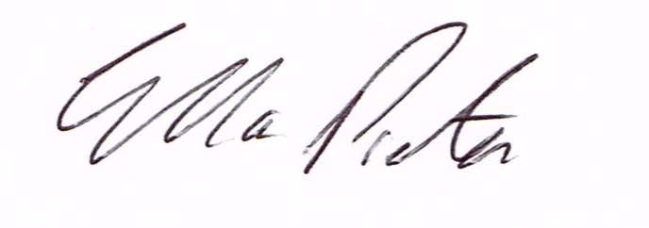
ELLA PRESTON
CLERK TO HIGHLEY PARISH COUNCIL.

AGENDA:

00. Parishioners Time (15 minutes) Speaking at a Meeting - You do not have the right to speak at a meeting unless invited to do so by the Council. If you wish to speak then you must contact the Clerk beforehand or make yourself known to the Clerk/Chair at the start of the meeting.

Declaration of any disclosable pecuniary interest in a matter to be discussed at the meeting. Members are reminded that they are required to leave the room during the discussion and voting on matters in which they have a disclosable pecuniary interest, whether or not the interest is entered in the register of member’s interest maintained by the monitoring officer.

01. Apologies for absence.

02. To confirm the minutes of the meetings dated 6th February 2018

03. Matters arising from minutes
Youth Council/Skate Park – Update – Cllr G.Court
Severn Centre/Halo Leisure – Replacement of Parish Council Storage Shed in Swimming Pool Grounds.
Annual Parish Meeting – Invites
Andy Oliver – Shropshire Council – Hedge Main Road/Grit Bins/Tree Netherton.

04. Correspondence:
SALC – February Bulletin
SALC – Town and Parish Forum – Wednesday 7th March2018.
Plus any correspondence that comes in prior to meeting.

05. To look at any planning applications received.

06. Annual Parish Council Grants

Bridgnorth Crime Prevention Panel – Crucial Crew Event for Highley School Children
Highley Dementia Group – Run by Elaine Moore at Rhea Hall Community Room.
Severn Centre – Summer Play Activities for Children,

07. Parish Council Identity Badges and Lanyards – To produce identity Badges for Highley Parish Council Members– Cllr. Court

08. Light Orchard Street/Coronation Street. – Report of meeting with Eon, STAR Housing and Cllr. George Court regarding additional lighting at the bottom of the alleyway of Orchard Street. To consider quotation and received from EON and decision taken on outcome.

09. Severn Valley Country Park Meeting – Report Cllrs. J.Marshall. N.Barker

10. Shropshire Councillors Report.

11. Finance: Accounts outstanding: Clerks Salary. Post Office Counters -Tax and National Insurance.
Severn Centre – Room Hire. Eon – Street Lighting. Ian Round – Village Maintenance Work,

Plus any cheques that come in prior to meeting.

CORRESPONDENCE
All correspondence and plans will be available for inspection by Parish Councillors prior to the meeting by contacting the clerk or from 6.30pm on the night of the Parish Council meeting. Parish Councillors if you wish any item to be discussed at the meeting please inform the clerk.

