HIGHLEY PARISH COUNCIL
Clerk: Mrs E Preston
81 Woodhill Road, Highley, Bridgnorth, Shropshire, WV16 6HU
Telephone: 01746 861979
Email: clerk@highleyparish.couk

Date: 26th October 2020
To: All Parish Council members
The Public and Press

You are summoned to attend an ordinary Meeting of Highley Parish Council which will be held via video link (Zoom) Tuesday 3rd November 2020 at 7pm for the transaction of business as set out in the agenda below.
Members of the public are invited to address the Council at the start of the meeting.

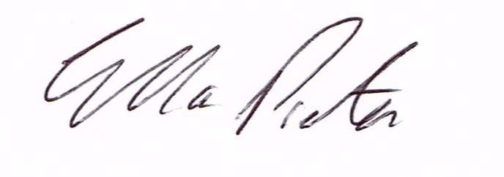
ELLA PRESTON
CLERK TO HIGHLEY PARISH COUNCIL.

AGENDA:

00. Parishioners Time (15 minutes) - Speaking at a Meeting - You do not have the right to speak at a meeting unless invited to do so by the Council. If you wish to speak /attend, then you must contact the Clerk beforehand so that a link to the meeting can be emailed to you. .

Declaration of any disclosable pecuniary interest in a matter to be discussed at the meeting. Members are reminded that they are required to leave the room during the discussion and voting on matters in which they have a disclosable pecuniary interest, whether the interest is entered in the register of member’s interest maintained by the monitoring officer.

01 Mr.T.Shrowsbee, Ms.Andrea Cox, – Shropshire Council- Housing Needs Survey

02 Apologies for absence and reasons for absence

03 To confirm the minutes of the meeting dated 13th October 2020

04. Matters Arising
CCTV – Start date November 2020.
Youth Project – Update from Cllr.Vinall.
Bus Shelter Village Centre – Update

05.Correspondence (All correspondence emailed to Councillors – if you wish anything discussed please contact the Clerk).
SALC – News in Brief – NALC Response to Planning White Paper .
National Salary Pay Awards
Climate Change Survey
Remembrance Sunday Covid Regulations
Local Plan Review
National Pavement Parking Survey
Keir – Mr. George Frost-Jones – details of work to be carried out on B4555 Borle Mill Junction to Junction of B4633
Shropshire Council – Civid Information

06 Planning
Reference: 20/04166/FUL (validated: 13/10/2020) - Address: 30 Hazelwells Road, Highley, WV16 6DJ - Proposal: Erection of two storey side extension

07..Cemetry Land /Burial Authority - to discuss options

08.Report from Monthly Meeting with Severn Centre

09 Shropshire Councillors Report. Report attached.

10. Finance: Clerks Salary - HMRC – Tax and National Insurance. , S.J.Maintenance – Village Maintenance issues. Eon – CCTV Columns. Shorthouses – Skip Hire. N.Power – Street lighting. . Plus, any other invoices received prior to meeting

