HIGHLEY PARISH COUNCIL
Clerk: Mrs E Preston
81 Woodhill Road, Highley, Bridgnorth, Shropshire, WV16 6HU
Telephone: 01746 861979
Email: clerk@highleyparish.couk

Date: 24th September 2018
To: All Parish Council members
The Public and Press

You are summoned to attend an Ordinary Meeting of Highley Parish Council which will be held on Tuesday 2nd October 2018 at the SEVERN CENTRE, HIGHLEY at 7pm for the transaction of business as set out in the agenda below.
Members of the public are invited to address the Council at the start of the meeting.

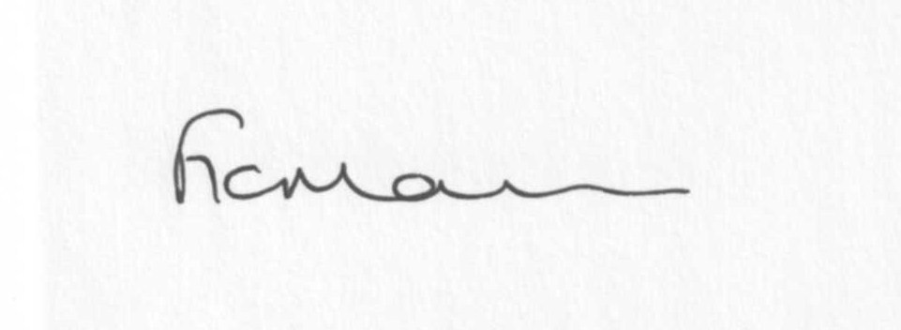
Mrs Freda Morris (01746 718453)
LOCUM CLERK TO HIGHLEY PARISH COUNCIL.

AGENDA:

00. Parishioners Time (15 minutes) - Speaking at a Meeting - You do not have the right to speak at a meeting unless invited to do so by the Council. If you wish to speak then you must contact the Clerk beforehand or make yourself known to the Clerk/Chair at the start of the meeting.

Declaration of any disclosable pecuniary interest in a matter to be discussed at the meeting. Members are reminded that they are required to leave the room during the discussion and voting on matters in which they have a disclosable pecuniary interest, whether the interest is entered in the register of member’s interest maintained by the monitoring officer.

01. Apologies for absence

02. To confirm the minutes of the meeting dated 4th September 2018

03. Matters Arising
Response from Halo re: community facilities – email sent to Cllrs.
Village laybys – update, if available

04. Correspondence
Shropshire Council – notice of Temporary road closure – New England Lane – 18th October 2018
SALC – Fundamentals training – 25th October – Much Wenlock – no disabled access.
Community Infrastructure Levy (CIL) -copy sent out with agenda
Recover! The Shropshire DAAT Newsletter September 2018 – emailed out to Cllrs
Any other received after issue of agenda.

05. Planning
If any received after issue of agenda

06. – Memorial – Cllr. Bache – to look at and agree suitable memorial for Cllr. D. Bache.

07. Churchyard Burial Grounds – Report from meeting and terms of reference for Sub Committee – notes forwarded last month – any update received.

08. Village Maintenance – Report from meeting/Engagement of Lenghthsman – notes forwarded last month.

09. Police and Crime Commissioner – Smart water Scheme – email copy sent to all
Councillors last month

10.Remberance Day Parade/Commemorations/Silent Soldier – Cllr. Court. To consider parade and other forms of Remembrance including any expenditure agreement.

11. Christmas lights

12. B4555 – condition

13. Chelmarsh PC – invitation to nominate 2 Cllrs to meet regarding B4555 and the plans proposed at The Astbury to attend a meting to be agreed with Consultants.

14. Shropshire Councillors Report

15. Finance: Clerks Salary. HMRC – Tax and National Insurance. Poppy Wreath. Jodie Pietragallo (plant watering). Any other accounts received after issue of agenda

