HIGHLEY PARISH COUNCIL
Clerk: Mrs E Preston
81 Woodhill Road, Highley, Bridgnorth, Shropshire, WV16 6HU
Telephone: 01746 861979
8th December 2021
To: All members of Revenue and Resources Committee
The Public and Press
You are summoned to attend a Meeting of the Revenue and Resources Committee which will be held via Zoom on Thursday 16th December 2021 a t10.30 am for the transaction of business as set out in the agenda below.

Members of the public are invited to address the Council at the start of the meeting .Due to Covid Restrictions please contact the Clerk prior to the meeting to book a space.

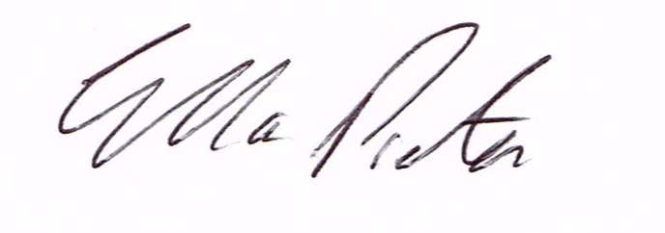
ELLA PRESTON
CLERK TO HIGHLEY PARISH COUNCIL.

AGENDA:

00. Parishioners Time (15 minutes) - Speaking at a Meeting - You do not have the right to speak at a meeting unless invited to do so by the Council. If you wish to speak /attend, then you must contact the Clerk beforehand so that a link to the meeting can be emailed to you.

Declaration of any disclosable pecuniary interest in a matter to be discussed at the meeting. Members are reminded that they are required to leave the room during the discussion and voting on matters in which they have a disclosable pecuniary interest, whether or not the interest is entered in the register of member’s interest maintained by the monitoring officer.

01 Apologies for absence and reasons for absence

02 To confirm the minutes of the meetings dated 28th September 2021

03. To look at Precept for 2022/2023

