HIGHLEY PARISH COUNCIL
Clerk: Mrs E Preston
81 Woodhill Road, Highley, Bridgnorth, Shropshire, WV16 6HU
Telephone: 01746 861979
Email: clerk@highleyparish.couk

Date: 28th August 2018
To: All Parish Council members
The Public and Press

You are summoned to attend an Ordinary Meeting of Highley Parish Council which will be held on Tuesday 4th September 2018 at the SEVERN CENTRE, HIGHLEY at 7pm for the transaction of business as set out in the agenda below.
Members of the public are invited to address the Council at the start of the meeting.
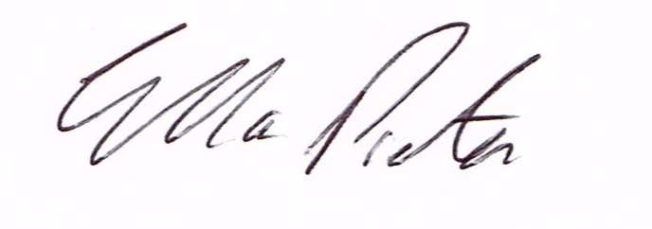
ELLA PRESTON
CLERK TO HIGHLEY PARISH COUNCIL.

AGENDA:

00. Parishioners Time (15 minutes) - Speaking at a Meeting - You do not have the right to speak at a meeting unless invited to do so by the Council. If you wish to speak then you must contact the Clerk beforehand or make yourself known to the Clerk/Chair at the start of the meeting.

Declaration of any disclosable pecuniary interest in a matter to be discussed at the meeting. Members are reminded that they are required to leave the room during the discussion and voting on matters in which they have a disclosable pecuniary interest, whether the interest is entered in the register of member’s interest maintained by the monitoring officer.

01. Apologies for absence

02. To confirm the minutes of the meeting dated 3rd July 2018

03. Matters Arising
Community Speed Watch Scheme – information emailed to all Councillors.
Village Laybys – email sent to all Councillors.
Youth Council – Grant received from STAR for Skate/Scooter Training and New Equipment at Skate Park. £200 for training and £500 towards new equipment. Spencer Smith the professional Scooters rider has offered to assist with the design of the Park for a cost of £100.

04. Correspondence
Shropshire Council road repair work Arley View Close.
Town and Parish Forum – 3rd September 2018
Environmental Maintenance Grant – Information from Shropshire Council.
Community Enablement Team – update on current situation with regards to the Community Enablement Team.
Shropshire Council – Information on Business Basic Fund – information emailed to all Councillors
Shropshire Council – notice of Temporary road closure – New England Lane – 18th October 2018
SALC – Fundamentals training – 25th October – Much Wenlock
Severn Centre – Report from meeting regarding community facilities. – Cllr. Court.

05. Planning –
18/03032/OUT – Land Adj 5 Cherry Orchard, Severnside – PLANNING COMMITTEE decision – No objections provided is was on the same footprint and that all ecological recommendations were considered.

Planning Decision:
18/02417/FUL – Change of use from a barber shop to a dog grooming salon. DECISION: GRANT PERMISSION.

06. – Memorial – Cllr. Bache – to look at and agree suitable memorial for Cllr. D. Bache.

07. Churchyard Burial Grounds – Report from meeting and terms of reference for Sub Committee – notes enclosed.

08. Village Maintenance – Report from meeting/Engagement of Lenghthsman – notes enclosed.

09. Police and Crime Commissioner – Smart water Scheme – email copy sent to all
Councillors

10.Remberance Day Parade/Commemorations – Cllr. Court. To consider parade and other forms of Remembrance.

11. Shropshire Councillors Report

12. Finance: Clerks Salary. HMRC – Tax and National Insurance. Severn Centre Trust – Room Hire, Viking Direct Stationery . Eon – Street Lighting. N.Power – Street Lighting. Spencer Smith – Skate Park Training Day – August.

