HIGHLEY PARISH COUNCIL
Clerk: Mrs E Preston
81 Woodhill Road, Highley, Bridgnorth, Shropshire, WV16 6HU
Telephone: 01746 861979
Email: prestonhighleypc@aol.com
www.highleyparish.com

Date: 18th April 2017
To: All Finance and Resources committee members Cllr. M.Brooks, Cllr.R.Broome, Cllr.J.Law, Cllr. D.Thakrar, Cllr. A.Honeybourne, Cllr N.Barker, Cllr. J.Marshall
The Public and Press

You are summoned to attend a meeting of the Finance and Resources Committee which will be held on WEDNESDAY 26th April 2017 at 6.30pm at the SEVERN CENTRE, HIGHLEY for the transaction of business as set out in the agenda below.

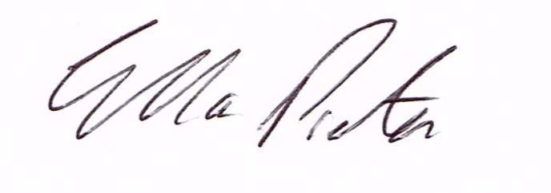
ELLA PRESTON
CLERK TO HIGHLEY PARISH COUNCIL.

AGENDA:

Declaration of any disclosable pecuniary interest in a matter to be discussed at the meeting. Members are reminded that they are required to leave the room during the voting on matters in which they have a disclosable pecuniary interest, whether or not the interest is entered in the register of member’s interest maintained by the monitoring officer.

01. Apologies for absence
02. To confirm minutes of meeting held on 4th January 2017
03. To look at accounts for year-end 31st March 2017

