HIGHLEY PARISH COUNCIL
Clerk: Mrs E Preston
81 Woodhill Road, Highley, Bridgnorth, Shropshire, WV16 6HU
Telephone: 01746 861979
Email: prestonhighleypc@aol.com

Date: 13th April 2016
To: All Finance and Resources committee members (Cllr. M.Brooks, Cllr.R.Brome, Cllr.J.Law,Cllr.D.Thakrar,Cllr.A.Honeybourne)
The Public and Press

You are summoned to attend a meeting of the Finance and Resources Committee which will be held on Wednesday 13th July 2016 at the SEVERN CENTRE, HIGHLEY at 9.30pm for the transaction of business as set out in the agenda below.

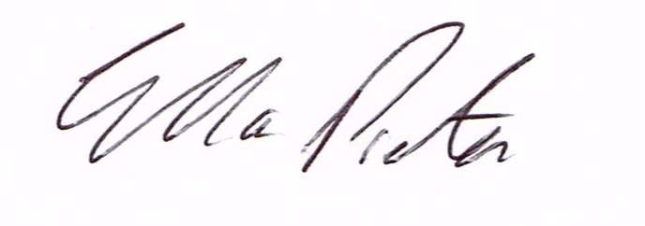
ELLA PRESTON
CLERK TO HIGHLEY PARISH COUNCIL.
5th July 2016

AGENDA:

Declaration of any disclosable pecuniary interest in a matter to be discussed at the meeting. Members are reminded that they are required to leave the room during the voting on matters in which they have a disclosable pecuniary interest, whether or not the interest is entered in the register of member’s interest maintained by the monitoring officer.

01. Apologies for absence
02. Minutes of previous meeting held 27th April 2016
03. To look at the CIL regulations

