HIGHLEY PARISH COUNCIL
Clerk: Mrs E Preston
81 Woodhill Road, Highley, Bridgnorth, Shropshire, WV16 6HU
Telephone: 01746 861979
Email: clerk@highleyparish.couk

Date: 25th June 2018
To: All Parish Council members
The Public and Press

You are summoned to attend an Ordinary Meeting of Highley Parish Council which will be held on Tuesday 3rd July 2018 at the SEVERN CENTRE, HIGHLEY at 7pm for the transaction of business as set out in the agenda below.
Members of the public are invited to address the Council at the start of the meeting.
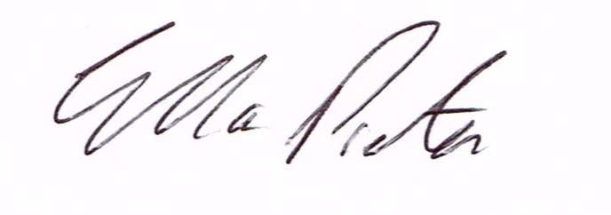
ELLA PRESTON
CLERK TO HIGHLEY PARISH COUNCIL.

AGENDA:

00. Parishioners Time (15 minutes) - Speaking at a Meeting - You do not have the right to speak at a meeting unless invited to do so by the Council. If you wish to speak then you must contact the Clerk beforehand or make yourself known to the Clerk/Chair at the start of the meeting.

Declaration of any disclosable pecuniary interest in a matter to be discussed at the meeting. Members are reminded that they are required to leave the room during the discussion and voting on matters in which they have a disclosable pecuniary interest, whether the interest is entered in the register of member’s interest maintained by the monitoring officer.

01. Apologies for absence

02. To confirm the minutes of the meeting dated 3rd June 2018

03. Matters Arising
Youth Council/Skate Park – update from Meeting – Cllr. Court
Castle Inn – Update
Footpath Vicarage Lane/Rhea Hall - Update

04. Correspondence
SALC – June Bulletin
Shropshire Council – Road Closure – Highley Carnival
SALC – Town and Parish Council forum – Draft Notes
Severn Valley Country Park – Bulletin
Shropshire Council – Election Fees.
Information Commissioner – Registration Fees.
Shropshire Council – Mr.P.Nutting – Highways
Shropshire Council – Mr.P.Nutting – Community Enablement Team

05. Planning –
18/02555/FUL – Proposed Residential Development of land west of 5 Carlton Rise – Erection of one detached dwelling and associated works.
.
06. CIL Funds – Neighbourhood Fund and CIL Local. To look at projects for Cil Funds- from last meeting.

07. Shropshire Council – Grant Request of £4000 towards Severn Valley Country Park. .
08. St. Marys Churchyard – Maintenance Contract – Report from Meeting – Cllr. Court.
09. Resolution that under the Public Bodies (Admission to Meetings) Act 1960, the public and representatives of the press be excluded from the meeting during the consideration of the following item of business as publicity would be prejudicial to the public interest because of the confidential nature of the business to be transacted.
10. Shropshire Council – Options for Site Allocation.

11. Shropshire Councillors Report

12. Finance: Clerks Salary. HMRC – Tax and National Insurance. Severn Centre Trust – Room Hire, Viking Direct Stationery .Information Commissioner Data Protection Registration. Highly Gas Services – Pump for Water Bowser. June Guest – Plants. Jim Lilly – Plants. Shropshire Council – Election Fees

