HIGHLEY PARISH COUNCIL
Clerk: Mrs E Preston
81 Woodhill Road, Highley, Bridgnorth, Shropshire, WV16 6HU
Telephone: 01746 861979
Email: prestonhighleypc@aol.com

Date: 27th May 2016.
To: All Parish Council members
The Public and Press

You are summoned to attend the Annual meeting of Highley Parish Council which will be held on Tuesday7th June 2016 at the SEVERN CENTRE, HIGHLEY at 7.00pm for the transaction of business as set out in the agenda below.
Members of the public are invited to address the Council at the start of the meeting.

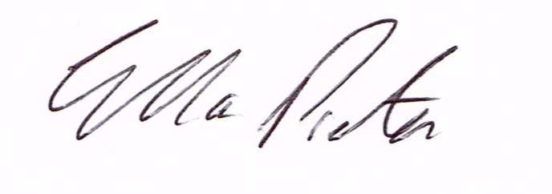
ELLA PRESTON
CLERK TO HIGHLEY PARISH COUNCIL.

AGENDA:

00. Parishioners Time (15 minutes)

Declaration of any disclosable pecuniary interest in a matter to be discussed at the meeting. Members are reminded that they are required to leave the room during the discussion and voting on matters in which they have a disclosable pecuniary interest, whether or not the interest is entered in the register of member’s interest maintained by the monitoring officer.

01. Apologies for absence. J.Marshall.

02. To confirm the minutes of the meeting dated 5th April 2016
03. Matters arising from minutes:-
04. Correspondence:
05. To look at any planning applications received.
06. End of year Parish Council Accounts – Internal Auditors Report
07. Report from meeting with Chris Edwards – Area Commission Shropshire Council
08. Roads – Cllr.Phipson
09.
12. Shropshire Councillors Report.
13. Finance: Accounts outstanding: Clerks Salary. Tax and National Insurance.
Eon – Street Lighting. Shropshire Council - Rent of Allotment Land Hagg Corner
SALC – D.Tremellen – Training
Plus any cheques that come in prior to meeting.

CORRESPONDENCE
All correspondence and plans will be available for inspection by Parish Councillors prior to the meeting by contacting the clerk or from 6.30pm on the night of the Parish Council meeting. Parish Councillors if you wish any item to be discussed at the meeting please inform the clerk.

