HIGHLEY PARISH COUNCIL
Clerk: Mrs E Preston
81 Woodhill Road, Highley, Bridgnorth, Shropshire, WV16 6HU
Telephone: 01746 861979
Email: clerk@highleyparish.co.uk

Date: 7th January 2019
To: All Parish Council members Amended agenda
The Public and Press

You are summoned to attend an Ordinary Meeting of Highley Parish Council which will be held on Tuesday 15th January 2019 at the SEVERN CENTRE, HIGHLEY at 7pm for the transaction of business as set out in the agenda below.
Members of the public are invited to address the Council at the start of the meeting.
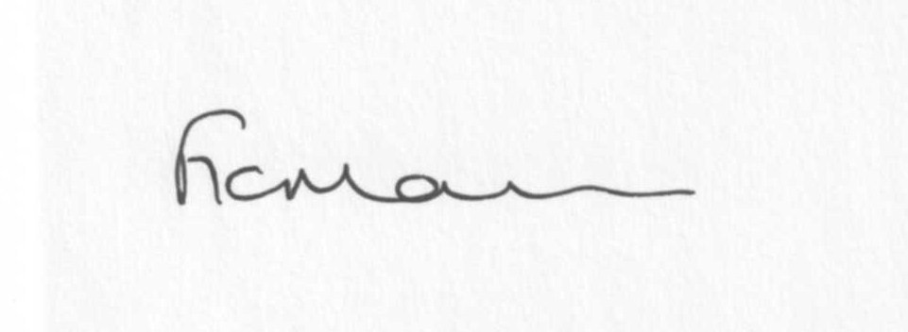
Mrs Freda Morris (01746 718453)
LOCUM CLERK TO HIGHLEY PARISH COUNCIL.

AGENDA:

00. Parishioners Time (15 minutes) - Speaking at a Meeting - You do not have the right to speak at a meeting unless invited to do so by the Council. If you wish to speak then you must contact the Clerk beforehand or make yourself known to the Clerk/Chair at the start of the meeting.
Declaration of any disclosable pecuniary interest in a matter to be discussed at the meeting. Members are reminded that they are required to leave the room during the discussion and voting on matters in which they have a disclosable pecuniary interest, whether the interest is entered in the register of member’s interest maintained by the monitoring officer.

01. Apologies for absence:

02. To confirm the minutes of the meeting dated 4th December 2018

03. Matters Arising
Response from Halo re: community facilities – any update
Village laybys – update, if available
Grit bin – update from Cllr Tremellen

04. Precept:
a) To discuss report from Revenue and Resources and agree precept for 2019/20
b) Clerks salary

05. Correspondence
Letter from Highley Park Homes re: defibrillator
Letter from June Guest re: hanging baskets/flowers
SC – Precept letter
Any other received after issue of agenda.

06. Planning:
a) 18/05301/TCA – Cut back selected branches and reduce crown by up to 3 metres (see photo) of two Sycamore within Highley Conservation Area. Applicant Mr D Charles, Highley Church, Highley
d) any others received after issue of agenda

07. Village Clock: - Cllr Court – any update/account for work

08. Churchyard Burial Grounds – any update received.

09. Village Maintenance – To discuss any applications received

10. Police and Crime Commissioner – Smart water Scheme – any update

11. B4555 – condition – any update

12. Chelmarsh PC – The Astbury - any update

13. Shropshire Councillors Report

14. Environmental Maintenance Grant - any update

15. Bus Shelter – top end of Clee View – Cllr A Honeybourne

16. Local Plan – Preferred Site – update from meeting

17. CCTV upgrade

18. Finance:
a) Accounts for payment:
Clerks Salary – Mrs M E Preston.
HMRC – Tax and National Insurance.
Mrs F Morris account
Bowling Club donation
Eon accounts
Skatepark – to discuss financial support for this project
c) Any other accounts received after issue of agenda

19. Items for next agenda:

20. Date of next meeting: 5th February 2019

